COMP2322 Project Report

Cheung Kei Yau
23088621d

- Design and Implementation
The multi-thread web server is implemented with python and tested on Windows. Python standard libraries socket, threading, time, os, sys and datetime is used.

The server handles HTTP requests from a client socket and open with the port. It supports serving text and image files from a specified directory ./web. The server also handles persistent connections with 10 seconds timeout and supports the “If-Modified-Since” header for caching.

1.1 functions
- available_port(host, port) is used to find a port which is available recursively on the given host. If the initial port is used, the port will be added by 1 until there is an available port.
[on Port 8000]
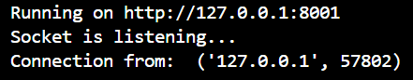
[on Port 8001, Port 8000 is in use]
- getHeader(status_code, file_type, last_modified): generates HTTP response headers based on the status code, file type, and last modified time. There are a total of 6 response status: 200 OK, 304 Not Modified, 400 Bad Request, 403 Forbidden, 404 File Not Found and 415 Unsupported Media Type.
- last_modified(file_path): returns the last modified time of a file in HTTP date format.
- webServer(client_socket, client_address): handles client requests, processes GET and HEAD methods, and sends appropriate HTTP responses.

1.2 hosting
The host and port number are set to 127.0.0.1 and 8000 respectively by default. The server listens for incoming connections on the specific host and port, handles each client connection in a separate thread, and serves the HTML and image files from the directory “web”. It also records client hostname or IP address, access time, requested file name and response type for each record in the log file named “log.txt”.

1.3 Keep-alive
The keep-alive timeout is set to 10 seconds and maximum100 seconds. The connection will be timeout if no request after 10 seconds. After a request, the web server will continue to receive requests from client and consider if it is persistent connection or not.
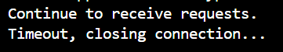

- program execution
- put the request source files into folder “web”
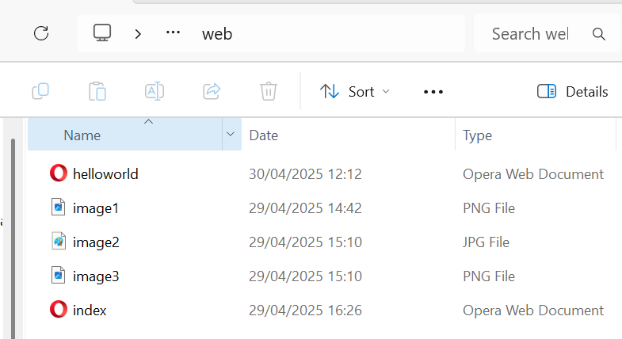
- type "py source_code_23088621d.py" on terminal to start the server program.
3. copy the website with port and visit this website on client. The URL should be “http://127.0.0.1:<PORT>/<request text or image file>”. Below is an example of the URL:
http://127.0.0.1:8000/helloworld.html
- Testing Cases
To access the server, use a web browser, or an HTTP client such as curl or Postman. Make sure run the script before visiting the web.

Test for 200 ok
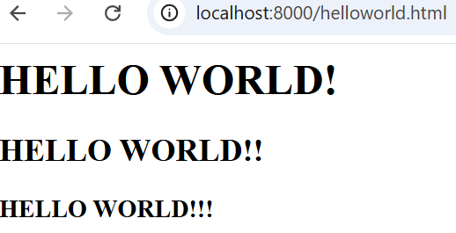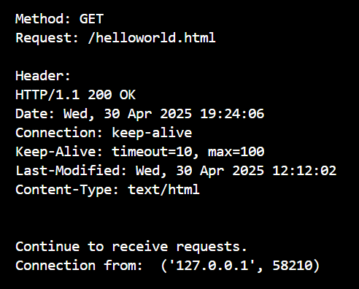
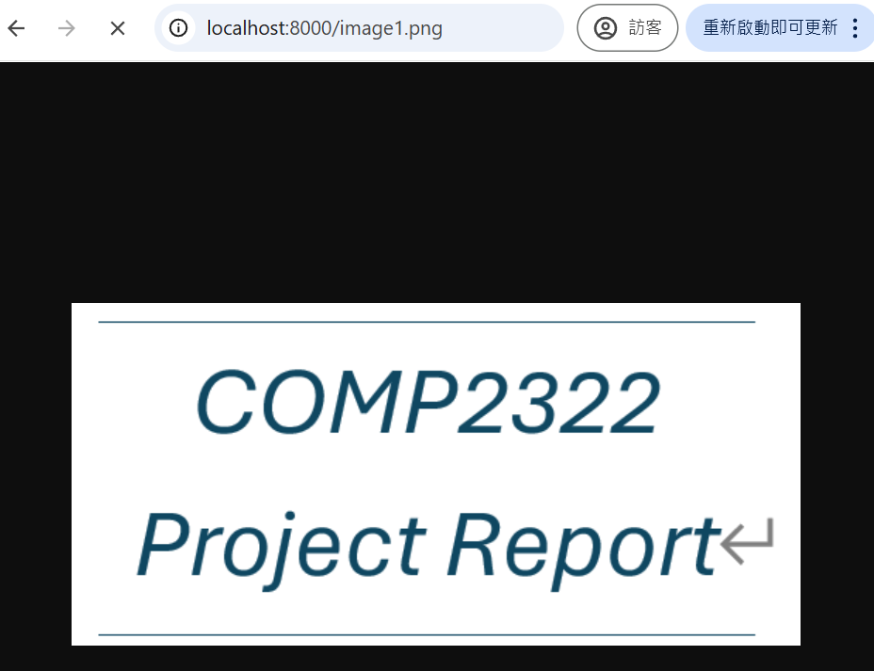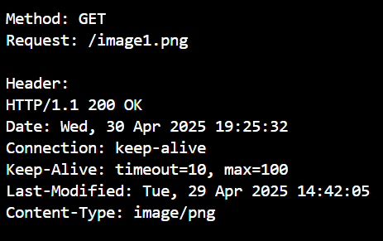

Test for 404 File Not Found
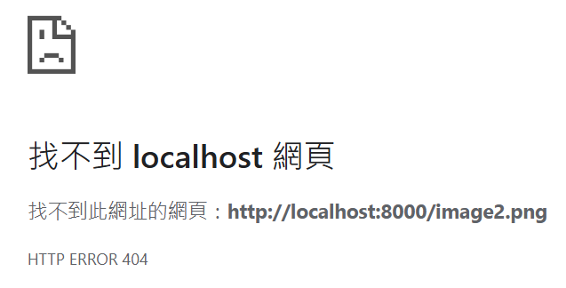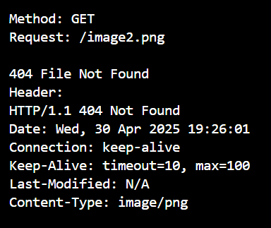

Test for 403 Forbidden
The test is done by changing the property of “image3”, by denying read permission for authenticated users.
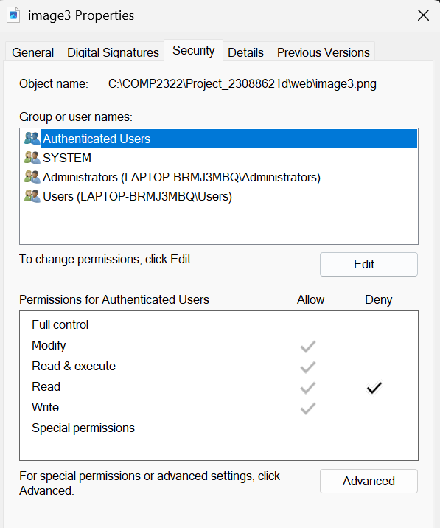
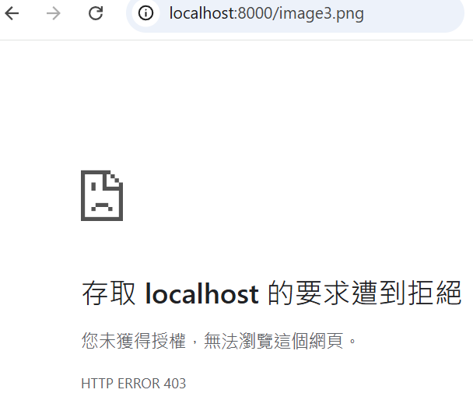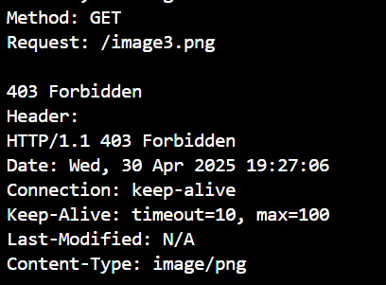

Test for 400 Bad Request
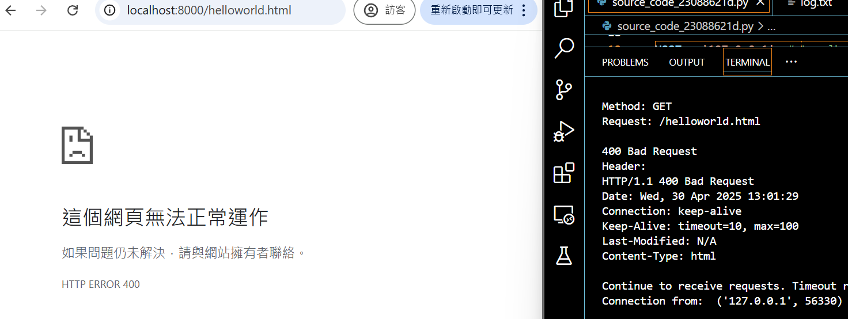

Test for 304 Not Modified
The test is done by “curl” command in the terminal.
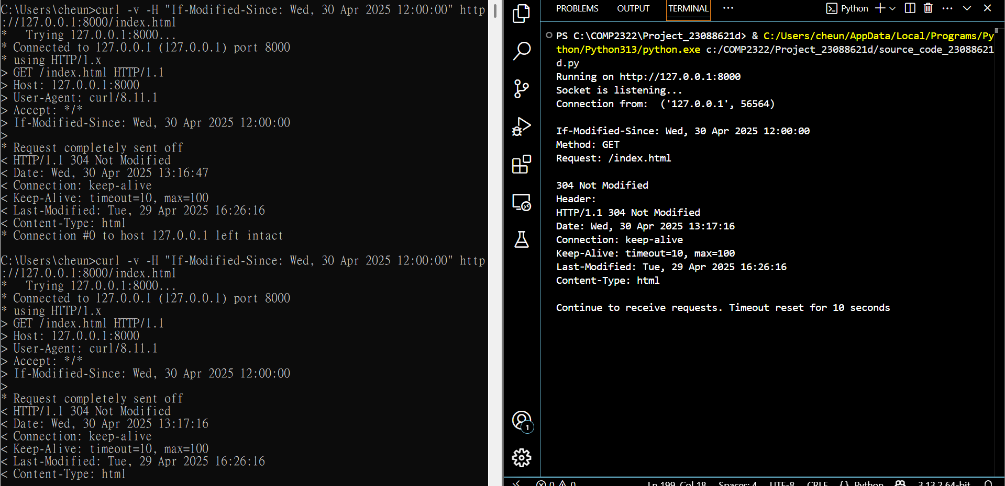
Test for 415 Unsupported Media Type
The test is done by requesting “image1.pdf” while pdf is not a supported type.
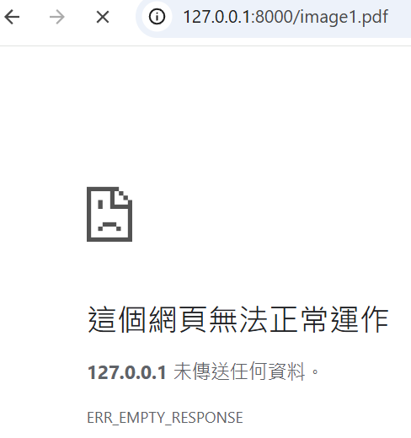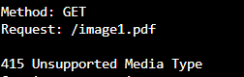

- Log file
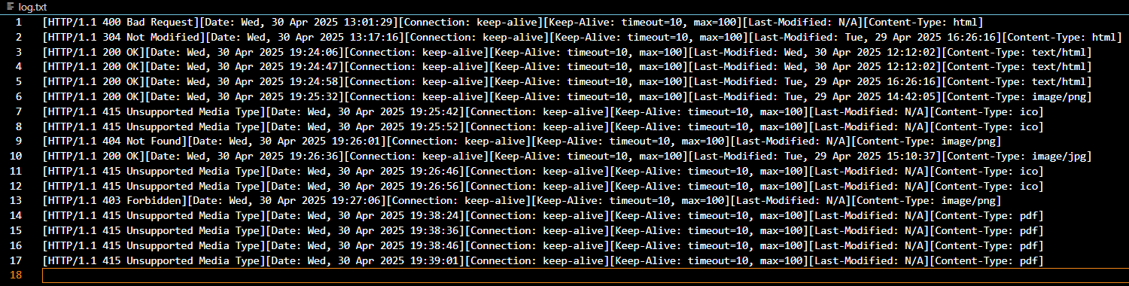

- README file
